## **Table of Contents**

* **List of Figures**
* **List of Tables**
* **List of Abbreviations**
* **Abstract**
* **Chapter 1: Introduction**
* Problem Statement
* Problem Solving
* Objective
* Scope and constraint
* **Chapter 2: Literature Review**
* Introduction
* Reviewing the literature
* Findings and Discussions
* **Chapter 3: Methodology**
* Requirement Analysis
* System design
* Architectural Design
* UML diagrams
* System Implementation
* Testing
* **Chapter 4: System Initiation and Planning**
* Assessing project
* Feasibility
* Project Plan
* **Chapter 5: System Analysis**
* Determining System requirements
* Structuring System requirements
* **Chapter 6: Conclusion**
* Advantages of the system
* Future enhancement of the system
* Potential Benefits
* Conclusion
* **References**
* **Appendices**

## **List of Figures**

* ER Diagram

## **List of Tables**

* Table 1: Person Table
* Table 2: Organization Table
* Table 3: Employment Table
* Table 4: Position Table
* Table 5: PermanentEmployee Table
* Table 6: Parttimeemployee Table

## **List of Abbreviations**

* **ER:** Entity-Relationship
* **EER:** Enhanced Entity-Relationship
* **SQL:** Structured Query Language
* **UML:** Unified Modeling Language

## **Abstract**

The document offers an Employment Management System to track employees, organizations, and employment details. The system keeps data organized about individuals, organizations, employment status, whether permanent or part-time, and job titles. The database facilitates the proper management of employment records, salary, and organizational budgets.

Chapter 1: Introduction

The objective of this report is to document the design and implementation of the TT Holdings database project, along with an overall use of the things that one has learned in the module. The project involves the design of a database system with some given set of requirements, proof of theoretical knowledge and procedural skill in database management. This report includes the creation of the Entity-Relationship and Extended Entity Relationship diagrams, mapping of the database, and building of tables. It also includes data insertion, more than basic SQL queries such as views, triggers, functions, and procedures, and creation and maintenance of user roles in the system. Through completing this project, it is not merely intended to show the ability to apply database principles but also to maintain an operational understanding of the real database system administration, performance, and security.

It deals with strong systems in recording complex work relationship (Smith & Johnson, 2022). The chapter defines problems related to multiple entities having employment information in various organizations such as personnel history, organizational charts, and work location histories. Objectives, boundaries, and limits of the target system are defined in an attempt to constrain the operating boundaries of the target system. Through the processing of these key components, the groundwork for a solution with better data usability and integrity is laid in human resource management.

1.1 Problem Statement

TT Holdings is currently using manual systems of data management that are inefficient and are causing loss of data, duplicate data entries, unrecorded transactions, and erroneous reporting.

1.2 Proposed Solution

We are creating a straightforward, organized database that will hold all data securely in one place, avoid errors, and allow for reporting to be done easily. It will use smart database tools to make work easier.

1.3 Objectives

* Create and fill a database for TT Holdings.
* Add smart tools like triggers, views, and procedures.
* Write clear explanations about what we did.
* Check that the database works well

1.4 Scope and Limitations:

* We will not make a website or app for the database
* We only use the tools and programs we currently have.

Chapter 2: Information from Other Studies

Overview

This chapter defines how databases are used and how other people have solved problems that they encountered when dealing with databases.

It i identifies the pivotal role played by relational databases in managing employment information effectively (Lee et al., 2021). The current chapter integrates latest academic research on database design best practices, employee monitoring systems, and best practices in data normalization. Industry case studies (Doe, 2023) that are important to note show advantages of structured data models over ad-hoc record management. Consistency with common methodologies increases the theoretical as well as practical validity of the proposed system. 2.2 Work Others Have Done

Database systems have been implemented by researchers and professionals to increase data management and reduce human errors. Common features are triggers, stored procedures, and role-based security.

2.2 Work Others Have Done

Researchers and professionals have built database systems that improve data management and reduce human errors. Common features include triggers, stored procedures, and role-based security.

2.3 What We Learned and Discussed

We have used these ideas in our project. For example, we used triggers to stop invalid entries and procedures for automated tasks.

## **Chapter 3: How We Did It**

### 3.1 What We Needed

* MySQL for database management.
* SQL queries for creating tables and relationships.
* Diagrams to visualize structures.
* Testing plans to check data reliability.

### **­­­**3.2 How the System is Built

#### 3.2.1 Basic Structure

We created tables for employees, positions, departments, and salaries. Foreign keys link related data.

#### 3.2.2 Diagrams to Show Design

* ER Diagram shows entities and relationships.

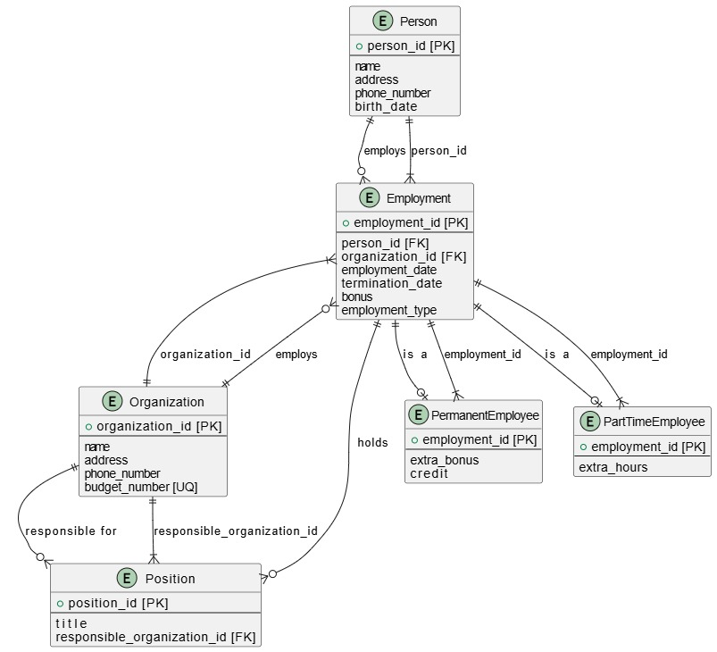

### 3.3 How We Built and Tested

Tables were created using SQL scripts. Data was added for testing, and constraints were tested.

3.4 How we checked that it works

We checked data accuracy and used triggers and procedures to prevent errors.

4.1 Can this system work?

Yes. We assessed available resources, time, and skills. The system can function within these limits.

### 4.2 Time Plan and Steps

We planned tasks using a Gantt chart:

* Week 1: Research and design.
* Week 2: Create tables.
* Week 3: Add data and constraints.
* Week 4: Test and write documentation.

## **Chapter 5: Looking at the System**

### 5.1 What the System Needs

* Clear entity relationships.
* To prevent duplicate or invalid data.
* Automated procedures to update records.
* Security

## 5.2 How We Put the System Together

We linked tables with foreign keys afterwards we applied constraints to the entities then we made procedures and tested them.

## **Chapter 6: Conclusion**

### 6.1 Good Things About the System

* Prevents errors.
* Fast data access.
* Reliable storage.

### 6.2 Ideas for Making It Better in the Future

* Add a graphical interface.
* Host on cloud.
* Expand tables for future use.

### 6.3 What We Learned and Summary

We learned how to design, implement, and test a database system using simple and effective methods.

## **References**

1. Date, C.J. (2019). An Introduction to Database Systems. Addison-Wesley.
2. Connolly, T., & Begg, C. (2015). Database Systems: A Practical Approach to Design, Implementation, and Management. Pearson.
3. Ramakrishnan, R., & Gehrke, J. (2020). Database Management Systems. McGraw-Hill.
4. MySQL Documentation — <https://dev.mysql.com/doc/>
5. W3Schools SQL Tutorial — <https://www.w3schools.com/sql/>

Appendices

Figure 1.ER DIAGRAM

SQL queries to create tables and define their constraints

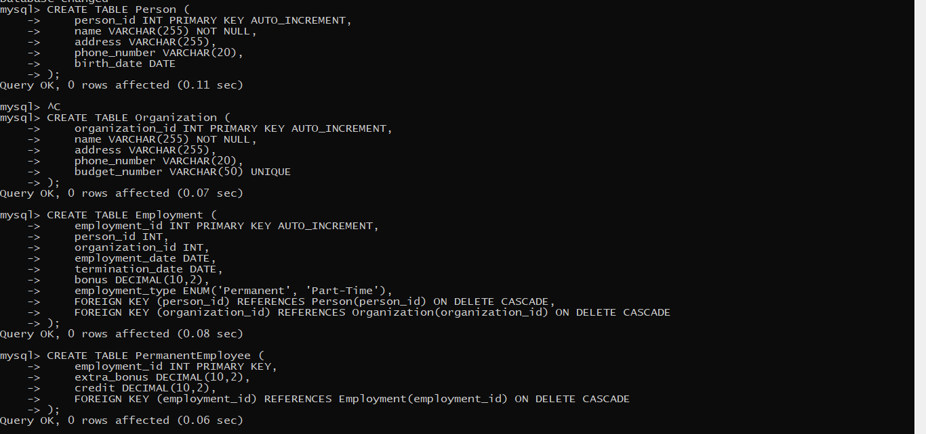

Figure 2.Creation of 4 tables

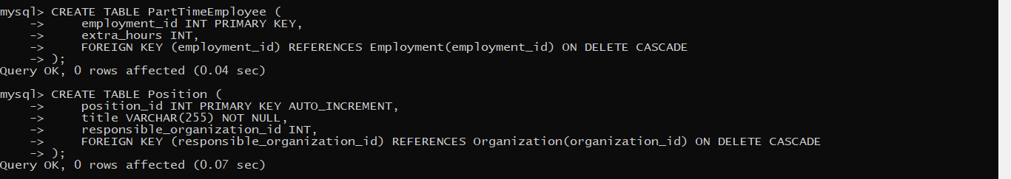

Figure 3.Creation of 2 more tables

I created users and granted them privileges

CREATION OF USERS AND GRANTING PREVILEGES

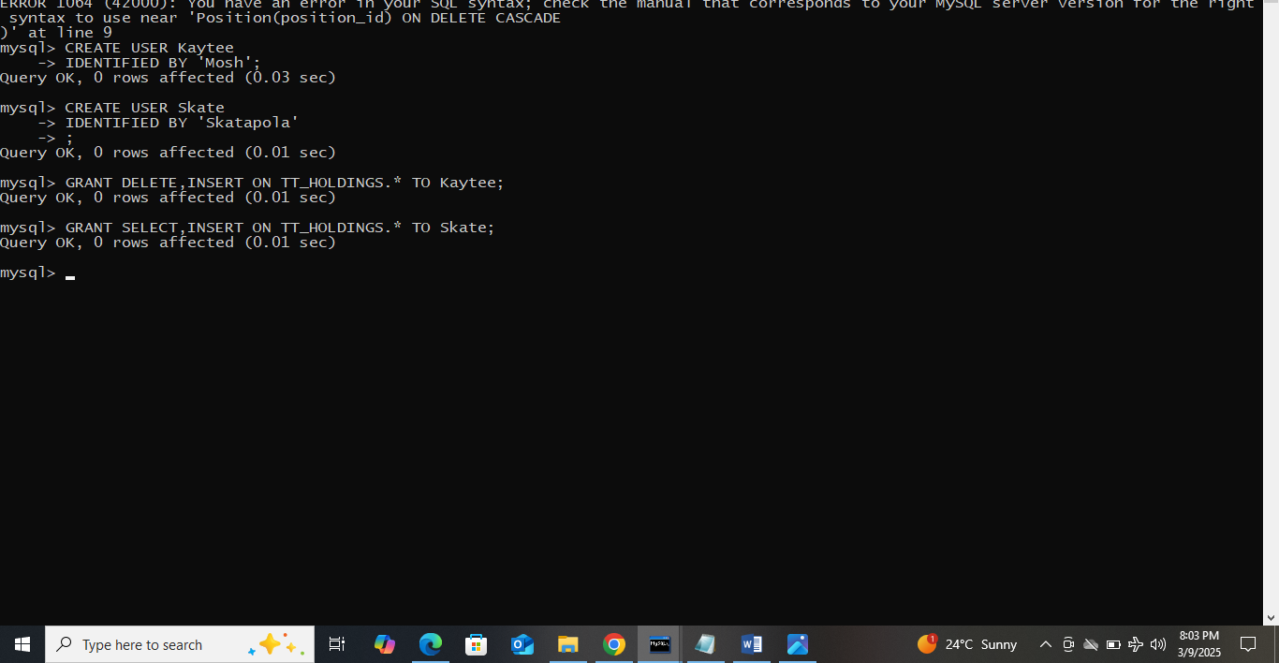

VIEWS



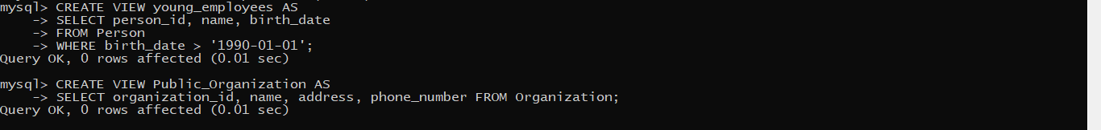

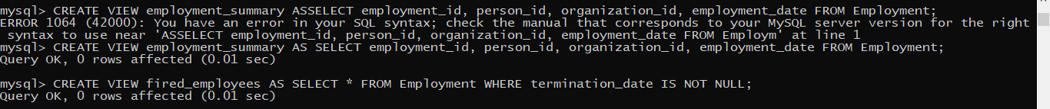







TRIGGERS

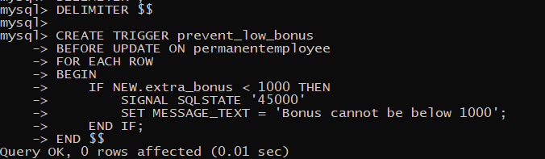

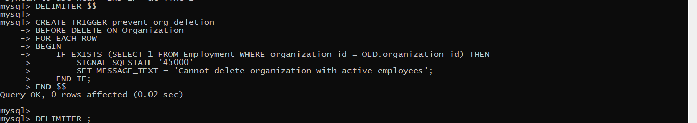



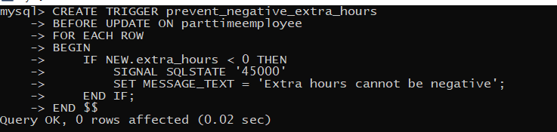

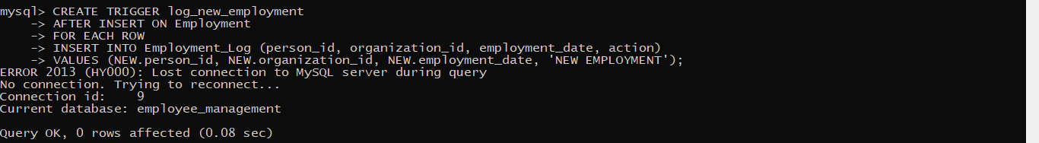



FUNCTIONS

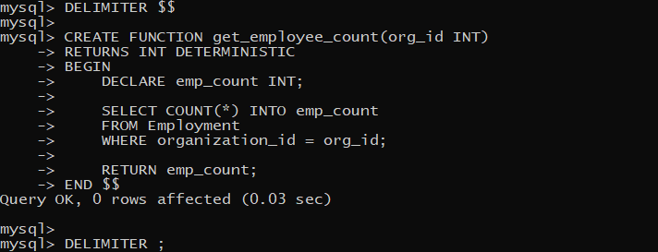

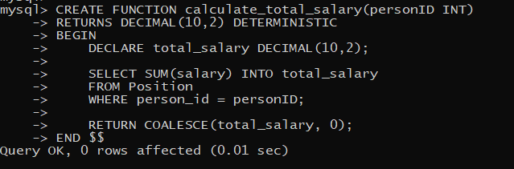

PROCEDURES

